教学管理系统

[元数据建模信息有限公司]

|  |
| --- |
| 教学管理系统参考案例 |

文档信息

|  |  |  |  |
| --- | --- | --- | --- |
| 项目名称： | 教学管理系统 | | |
| 项目经理： | 杨松<yangsong158@qq.com> | 模型编号： | 3.5.3 |
| 模型创建日期： | 2021-11-6 06:57:15 | 模型更新日期： | 2021-11-6 07:33:00 |
| 起草人： | 元数建模自动生成 | 文档创建日期： |  |
| 复审人： | 杨松<yangsong158@qq.com> | 复审日期： |  |
| 项目说明： | 教学管理系统参考案例 | | |
| 官方网站： | <http://www.chiner.com.cn/> | | |
| 开源代码： | <https://gitee.com/robergroup/chiner.git>  <https://gitee.com/robergroup/chiner-java.git> | | |
| 联系作者： |  | | |

# CHINER-教学管理系统

## 关系图

### TableRelations-[数据表关系图]

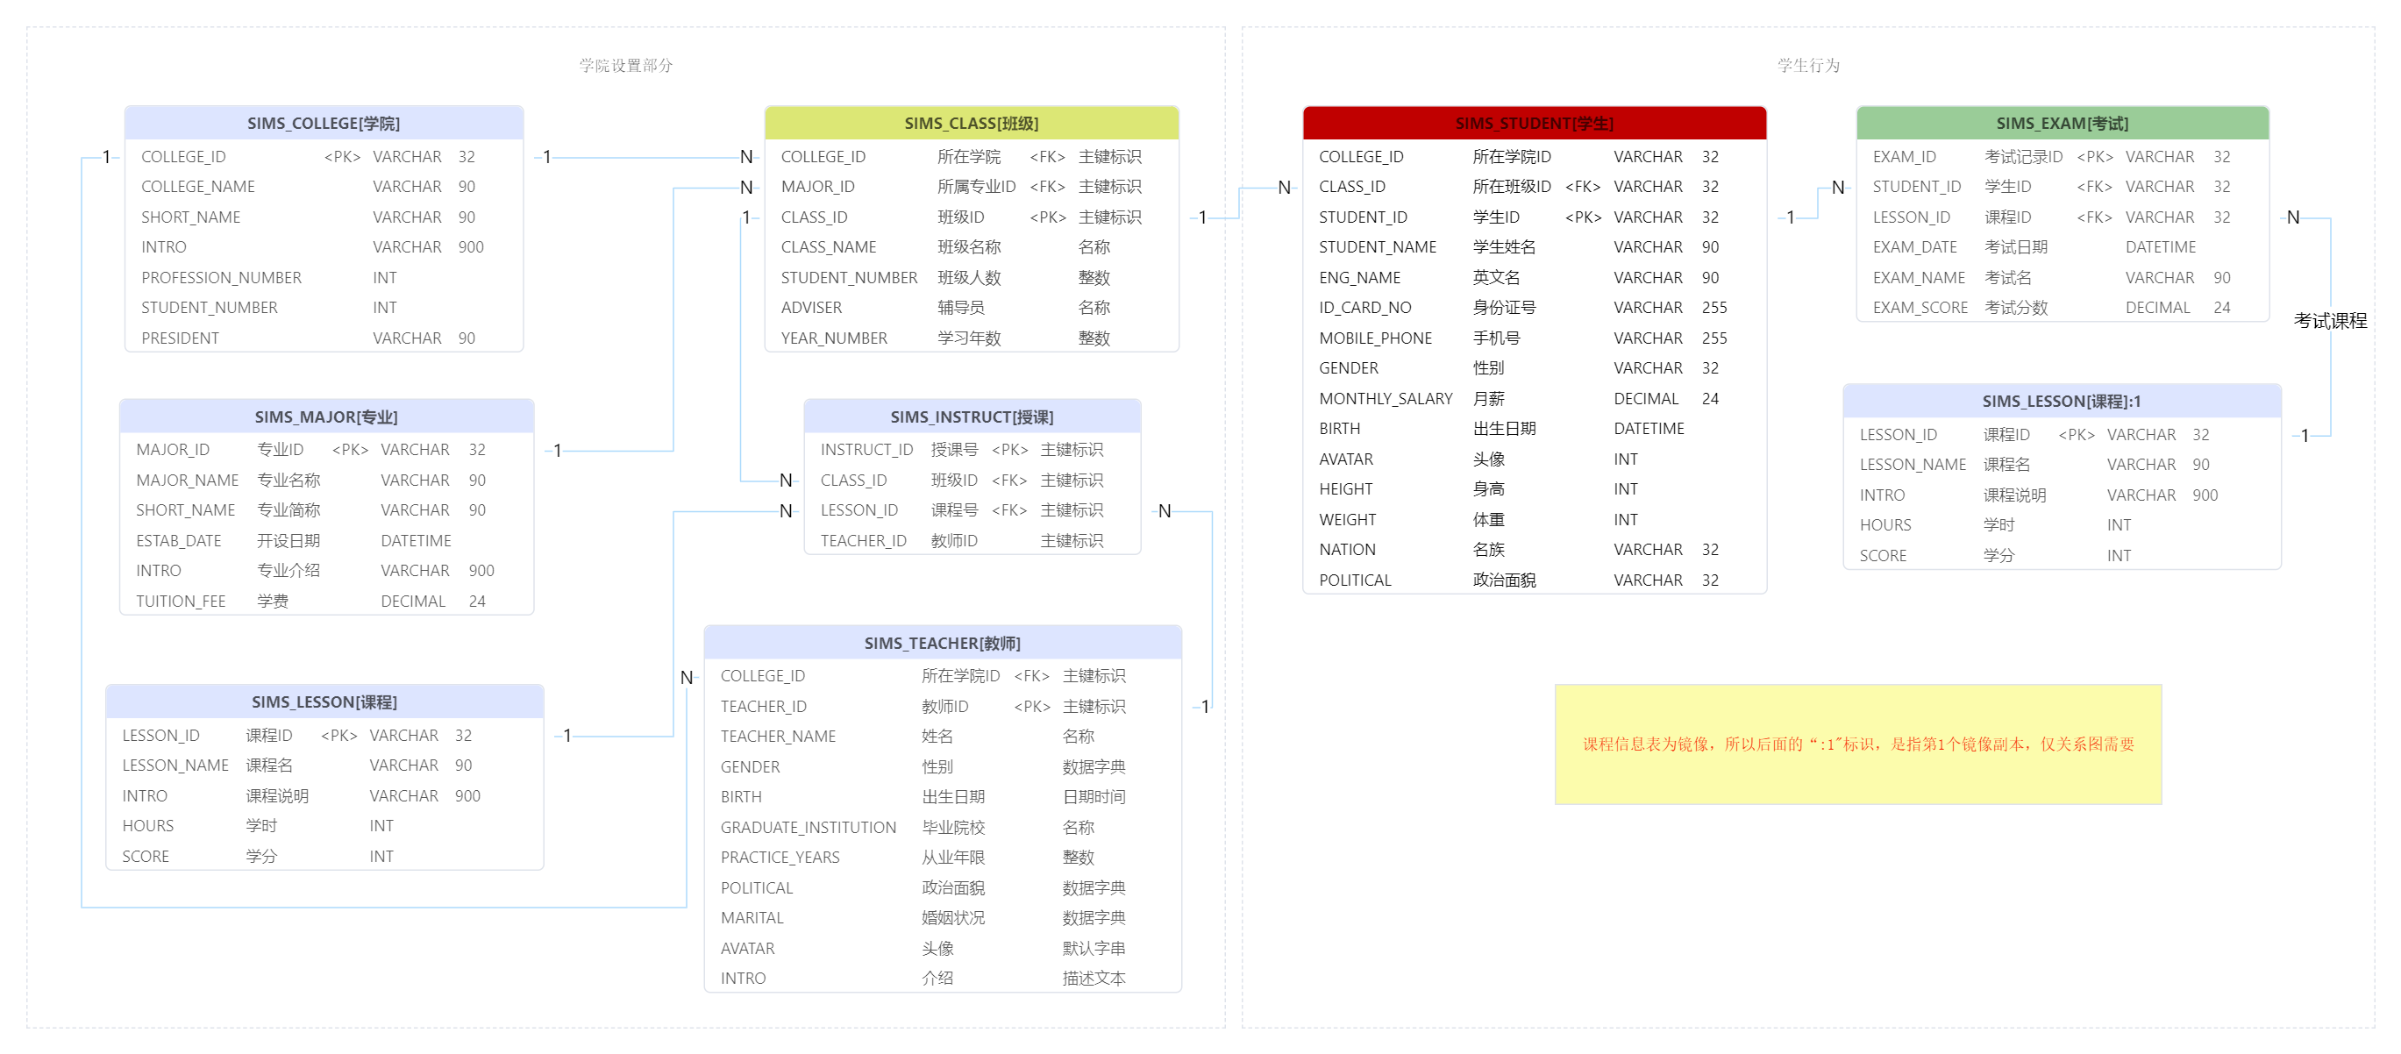

### KeyEntities-[关键业务对象]

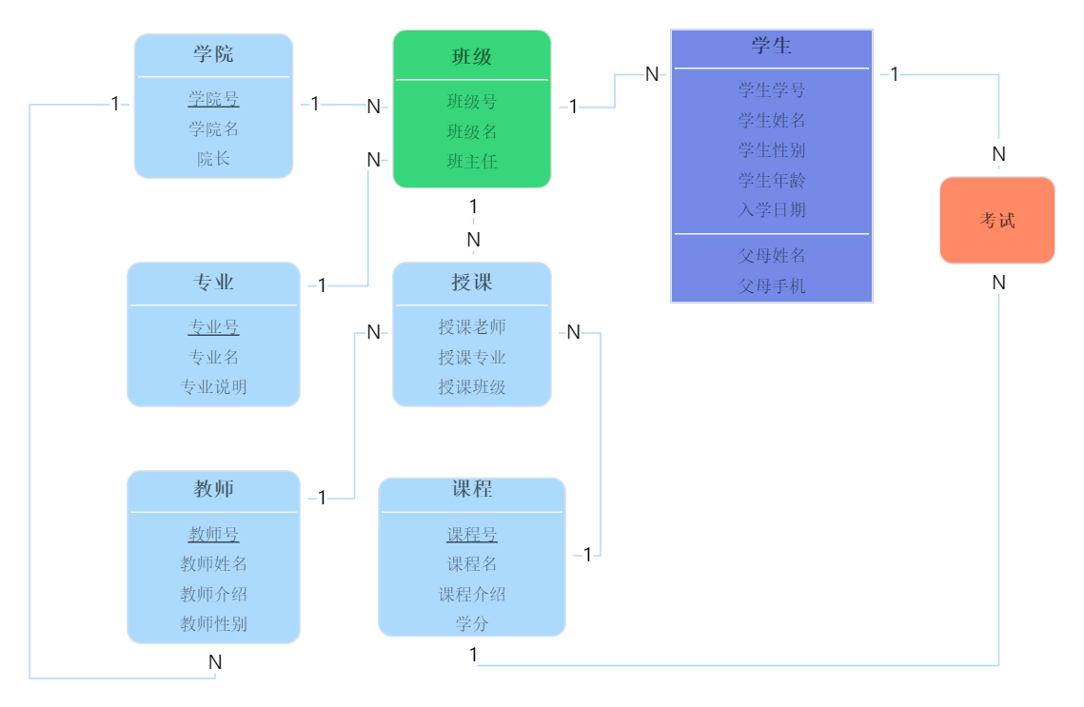

## 表清单

|  |  |  |  |
| --- | --- | --- | --- |
| **#** | **数据表** | **名称** | **备注说明** |
| 1 | SIMS_COLLEGE | 学院 |  |
| 2 | SIMS_MAJOR | 专业 |  |
| 3 | SIMS_CLASS | 班级 |  |
| 4 | SIMS_STUDENT | 学生 |  |
| 5 | SIMS_TEACHER | 教师 |  |
| 6 | SIMS_LESSON | 课程 |  |
| 7 | SIMS_INSTRUCT | 授课 |  |
| 8 | SIMS_EXAM | 考试 |  |
| 9 | SIMS_CLASS_FEE | 班费 |  |

## 表字段明细

### SIMS_COLLEGE [学院]

|  |  |  |  |  |  |  |  |
| --- | --- | --- | --- | --- | --- | --- | --- |
| **#** | **字段** | **名称** | **数据类型** | **主键** | **非空** | **默认值** | **备注说明** |
| 1 | COLLEGE_ID | 学院ID | VARCHAR(32) | √ | √ |  |  |
| 2 | COLLEGE_NAME | 学院名称 | VARCHAR(90) |  |  |  |  |
| 3 | SHORT_NAME | 学院简称 | VARCHAR(90) |  |  |  |  |
| 4 | INTRO | 学院介绍 | VARCHAR(900) |  |  |  |  |
| 5 | PROFESSION_NUMBER | 专业个数 | INT |  |  |  |  |
| 6 | STUDENT_NUMBER | 学生人数 | INT |  |  |  |  |
| 7 | PRESIDENT | 院长 | VARCHAR(90) |  |  |  |  |
| 8 | TENANT_ID | 租户号 | VARCHAR(32) |  |  |  |  |
| 9 | REVISION | 乐观锁 | INT |  |  |  |  |
| 10 | CREATED_BY | 创建人 | VARCHAR(32) |  |  |  |  |
| 11 | CREATED_TIME | 创建时间 | DATETIME |  |  |  |  |
| 12 | UPDATED_BY | 更新人 | VARCHAR(32) |  |  |  |  |
| 13 | UPDATED_TIME | 更新时间 | DATETIME |  |  |  |  |

### SIMS_MAJOR [专业]

|  |  |  |  |  |  |  |  |
| --- | --- | --- | --- | --- | --- | --- | --- |
| **#** | **字段** | **名称** | **数据类型** | **主键** | **非空** | **默认值** | **备注说明** |
| 1 | MAJOR_ID | 专业ID | VARCHAR(32) | √ | √ |  |  |
| 2 | MAJOR_NAME | 专业名称 | VARCHAR(90) |  |  |  |  |
| 3 | SHORT_NAME | 专业简称 | VARCHAR(90) |  |  |  |  |
| 4 | ESTAB_DATE | 开设日期 | DATETIME |  |  |  |  |
| 5 | INTRO | 专业介绍 | VARCHAR(900) |  |  |  |  |
| 6 | TUITION_FEE | 学费 | DECIMAL(24,6) |  |  |  |  |
| 7 | TENANT_ID | 租户号 | VARCHAR(32) |  |  |  |  |
| 8 | REVISION | 乐观锁 | INT |  |  |  |  |
| 9 | CREATED_BY | 创建人 | VARCHAR(32) |  |  |  |  |
| 10 | CREATED_TIME | 创建时间 | DATETIME |  |  |  |  |
| 11 | UPDATED_BY | 更新人 | VARCHAR(32) |  |  |  |  |
| 12 | UPDATED_TIME | 更新时间 | DATETIME |  |  |  |  |

### SIMS_CLASS [班级]

|  |  |  |  |  |  |  |  |
| --- | --- | --- | --- | --- | --- | --- | --- |
| **#** | **字段** | **名称** | **数据类型** | **主键** | **非空** | **默认值** | **备注说明** |
| 1 | COLLEGE_ID | 所在学院 | VARCHAR(32) |  |  |  |  |
| 2 | MAJOR_ID | 所属专业ID | VARCHAR(32) |  |  |  |  |
| 3 | CLASS_ID | 班级ID | VARCHAR(32) | √ | √ |  |  |
| 4 | CLASS_NAME | 班级名称 | VARCHAR(90) |  |  |  |  |
| 5 | STUDENT_NUMBER | 班级人数 | INT |  |  |  |  |
| 6 | ADVISER | 辅导员 | VARCHAR(90) |  |  |  |  |
| 7 | ESTAB_DATE | 成立时间 | DATETIME |  |  |  |  |
| 8 | YEAR_NUMBER | 学习年数 | INT |  |  |  |  |
| 9 | TENANT_ID | 租户号 | VARCHAR(32) |  |  |  |  |
| 10 | REVISION | 乐观锁 | INT |  |  |  |  |
| 11 | CREATED_BY | 创建人 | VARCHAR(32) |  |  |  |  |
| 12 | CREATED_TIME | 创建时间 | DATETIME |  |  |  |  |
| 13 | UPDATED_BY | 更新人 | VARCHAR(32) |  |  |  |  |
| 14 | UPDATED_TIME | 更新时间 | DATETIME |  |  |  |  |

### SIMS_STUDENT [学生]

|  |  |  |  |  |  |  |  |
| --- | --- | --- | --- | --- | --- | --- | --- |
| **#** | **字段** | **名称** | **数据类型** | **主键** | **非空** | **默认值** | **备注说明** |
| 1 | COLLEGE_ID | 所在学院ID | VARCHAR(32) |  | √ |  |  |
| 2 | CLASS_ID | 所在班级ID | VARCHAR(32) |  | √ |  |  |
| 3 | STUDENT_ID | 学生ID | VARCHAR(32) | √ | √ |  |  |
| 4 | STUDENT_NAME | 学生姓名 | VARCHAR(90) |  |  |  |  |
| 5 | ENG_NAME | 英文名 | VARCHAR(90) |  |  |  |  |
| 6 | ID_CARD_NO | 身份证号 | VARCHAR(255) |  |  |  |  |
| 7 | MOBILE_PHONE | 手机号 | VARCHAR(255) |  |  |  |  |
| 8 | GENDER | 性别 | VARCHAR(32) |  |  | 'M' |  |
| 9 | MONTHLY_SALARY | 月薪 | DECIMAL(24,6) |  |  |  |  |
| 10 | BIRTH | 出生日期 | DATETIME |  |  |  |  |
| 11 | AVATAR | 头像 | INT |  |  |  |  |
| 12 | HEIGHT | 身高 | INT |  |  |  |  |
| 13 | WEIGHT | 体重 | INT |  |  |  |  |
| 14 | NATION | 名族 | VARCHAR(32) |  |  | '01' |  |
| 15 | POLITICAL | 政治面貌 | VARCHAR(32) |  |  |  |  |
| 16 | MARITAL | 婚姻状况 | VARCHAR(32) |  |  | 'UNMARRIED' |  |
| 17 | DOMICILE_PLACE_PROVINCE | 籍贯（省） | VARCHAR(255) |  |  |  |  |
| 18 | DOMICILE_PLACE_CITY | 籍贯（市） | VARCHAR(255) |  |  |  |  |
| 19 | DOMICILE_PLACE_ADDRESS | 户籍地址 | VARCHAR(255) |  |  |  |  |
| 20 | HOBBY | 爱好 | VARCHAR(255) |  |  |  |  |
| 21 | INTRO | 简要介绍 | VARCHAR(900) |  |  |  |  |
| 22 | PRESENT_ADDRESS | 居住地址 | VARCHAR(255) |  |  |  |  |
| 23 | EMAIL | 电子邮件 | VARCHAR(255) |  |  |  |  |
| 24 | ENTRY_DATE | 入学日期 | DATETIME |  |  |  |  |
| 25 | STATUS | 状态 | VARCHAR(32) |  |  | 'Normal' |  |
| 26 | TENANT_ID | 租户号 | VARCHAR(32) |  |  |  |  |
| 27 | REVISION | 乐观锁 | INT |  |  |  |  |
| 28 | CREATED_BY | 创建人 | VARCHAR(32) |  |  |  |  |
| 29 | CREATED_TIME | 创建时间 | DATETIME |  |  |  |  |
| 30 | UPDATED_BY | 更新人 | VARCHAR(32) |  |  |  |  |
| 31 | UPDATED_TIME | 更新时间 | DATETIME |  |  |  |  |

### SIMS_TEACHER [教师]

|  |  |  |  |  |  |  |  |
| --- | --- | --- | --- | --- | --- | --- | --- |
| **#** | **字段** | **名称** | **数据类型** | **主键** | **非空** | **默认值** | **备注说明** |
| 1 | COLLEGE_ID | 所在学院ID | VARCHAR(32) |  | √ |  |  |
| 2 | TEACHER_ID | 教师ID | VARCHAR(32) | √ | √ |  |  |
| 3 | TEACHER_NAME | 姓名 | VARCHAR(90) |  |  |  |  |
| 4 | GENDER | 性别 | VARCHAR(32) |  |  | 'M' |  |
| 5 | BIRTH | 出生日期 | DATETIME |  |  |  |  |
| 6 | GRADUATE_INSTITUTION | 毕业院校 | VARCHAR(90) |  |  |  |  |
| 7 | PRACTICE_YEARS | 从业年限 | INT |  |  |  |  |
| 8 | POLITICAL | 政治面貌 | VARCHAR(32) |  |  |  |  |
| 9 | MARITAL | 婚姻状况 | VARCHAR(32) |  |  | 'UNMARRIED' |  |
| 10 | AVATAR | 头像 | VARCHAR(255) |  |  |  |  |
| 11 | INTRO | 介绍 | VARCHAR(900) |  |  |  |  |
| 12 | TENANT_ID | 租户号 | VARCHAR(32) |  |  |  |  |
| 13 | REVISION | 乐观锁 | INT |  |  |  |  |
| 14 | CREATED_BY | 创建人 | VARCHAR(32) |  |  |  |  |
| 15 | CREATED_TIME | 创建时间 | DATETIME |  |  |  |  |
| 16 | UPDATED_BY | 更新人 | VARCHAR(32) |  |  |  |  |
| 17 | UPDATED_TIME | 更新时间 | DATETIME |  |  |  |  |

### SIMS_LESSON [课程]

|  |  |  |  |  |  |  |  |
| --- | --- | --- | --- | --- | --- | --- | --- |
| **#** | **字段** | **名称** | **数据类型** | **主键** | **非空** | **默认值** | **备注说明** |
| 1 | LESSON_ID | 课程ID | VARCHAR(32) | √ | √ |  |  |
| 2 | LESSON_NAME | 课程名 | VARCHAR(90) |  |  |  |  |
| 3 | INTRO | 课程说明 | VARCHAR(900) |  |  |  |  |
| 4 | HOURS | 学时 | INT |  |  |  |  |
| 5 | SCORE | 学分 | INT |  |  |  |  |
| 6 | TENANT_ID | 租户号 | VARCHAR(32) |  |  |  |  |
| 7 | REVISION | 乐观锁 | INT |  |  |  |  |
| 8 | CREATED_BY | 创建人 | VARCHAR(32) |  |  |  |  |
| 9 | CREATED_TIME | 创建时间 | DATETIME |  |  |  |  |
| 10 | UPDATED_BY | 更新人 | VARCHAR(32) |  |  |  |  |
| 11 | UPDATED_TIME | 更新时间 | DATETIME |  |  |  |  |

### SIMS_INSTRUCT [授课]

|  |  |  |  |  |  |  |  |
| --- | --- | --- | --- | --- | --- | --- | --- |
| **#** | **字段** | **名称** | **数据类型** | **主键** | **非空** | **默认值** | **备注说明** |
| 1 | INSTRUCT_ID | 授课号 | VARCHAR(32) | √ | √ |  |  |
| 2 | CLASS_ID | 班级ID | VARCHAR(32) |  |  |  |  |
| 3 | LESSON_ID | 课程号 | VARCHAR(32) |  |  |  |  |
| 4 | TEACHER_ID | 教师ID | VARCHAR(32) |  |  |  |  |
| 5 | TENANT_ID | 租户号 | VARCHAR(32) |  |  |  |  |
| 6 | REVISION | 乐观锁 | INT |  |  |  |  |
| 7 | CREATED_BY | 创建人 | VARCHAR(32) |  |  |  |  |
| 8 | CREATED_TIME | 创建时间 | DATETIME |  |  |  |  |
| 9 | UPDATED_BY | 更新人 | VARCHAR(32) |  |  |  |  |
| 10 | UPDATED_TIME | 更新时间 | DATETIME |  |  |  |  |

### SIMS_EXAM [考试]

|  |  |  |  |  |  |  |  |
| --- | --- | --- | --- | --- | --- | --- | --- |
| **#** | **字段** | **名称** | **数据类型** | **主键** | **非空** | **默认值** | **备注说明** |
| 1 | EXAM_ID | 考试记录ID | VARCHAR(32) | √ | √ |  |  |
| 2 | STUDENT_ID | 学生ID | VARCHAR(32) |  |  |  |  |
| 3 | LESSON_ID | 课程ID | VARCHAR(32) |  |  |  |  |
| 4 | EXAM_DATE | 考试日期 | DATETIME |  |  |  |  |
| 5 | EXAM_NAME | 考试名 | VARCHAR(90) |  |  |  |  |
| 6 | EXAM_SCORE | 考试分数 | DECIMAL(24,6) |  |  |  |  |
| 7 | TENANT_ID | 租户号 | VARCHAR(32) |  |  |  |  |
| 8 | REVISION | 乐观锁 | INT |  |  |  |  |
| 9 | CREATED_BY | 创建人 | VARCHAR(32) |  |  |  |  |
| 10 | CREATED_TIME | 创建时间 | DATETIME |  |  |  |  |
| 11 | UPDATED_BY | 更新人 | VARCHAR(32) |  |  |  |  |
| 12 | UPDATED_TIME | 更新时间 | DATETIME |  |  |  |  |

### SIMS_CLASS_FEE [班费]

|  |  |  |  |  |  |  |  |
| --- | --- | --- | --- | --- | --- | --- | --- |
| **#** | **字段** | **名称** | **数据类型** | **主键** | **非空** | **默认值** | **备注说明** |
| 1 | TENANT_ID | 租户号 | VARCHAR(32) |  |  |  |  |
| 2 | REVISION | 乐观锁 | VARCHAR(32) |  |  |  |  |
| 3 | CREATED_BY | 创建人 | VARCHAR(32) |  |  |  |  |
| 4 | CREATED_TIME | 创建时间 | DATETIME |  |  |  |  |
| 5 | UPDATED_BY | 更新人 | VARCHAR(32) |  |  |  |  |
| 6 | UPDATED_TIME | 更新时间 | DATETIME |  |  |  |  |

## 数据字典明细

### Gender [性别]

|  |  |  |  |
| --- | --- | --- | --- |
| **#** | **代码** | **名称** | **备注说明** |
| 1 | M | 男 |  |
| 2 | F | 女 |  |
| 3 | U | 未知 |  |

### Political [政治面貌]

|  |  |  |  |
| --- | --- | --- | --- |
| **#** | **代码** | **名称** | **备注说明** |
| 1 | 10 | 共青团员 |  |
| 2 | 20 | 中共党员 |  |
| 3 | 30 | 民主党派 |  |
| 4 | 40 | 群众 |  |
| 5 | 90 | 未知 |  |

### Marital [婚姻状况]

|  |  |  |  |
| --- | --- | --- | --- |
| **#** | **代码** | **名称** | **备注说明** |
| 1 | UNMARRIED | 未婚 |  |
| 2 | MARRIED | 已婚 |  |
| 3 | WIDOWED | 丧偶 |  |
| 4 | DIVORCE | 离婚 |  |
| 5 | UNSPECIFIED | 未说明 |  |

### StudentStatus [学生状态]

|  |  |  |  |
| --- | --- | --- | --- |
| **#** | **代码** | **名称** | **备注说明** |
| 1 | Normal | 正常 |  |
| 2 | Graduated | 毕业 |  |
| 3 | Studied | 肄业 |  |
| 4 | Stop | 休学 |  |

### GBNation [民族]

|  |  |  |  |
| --- | --- | --- | --- |
| **#** | **代码** | **名称** | **备注说明** |
| 1 | 01 | 汉族 |  |
| 2 | 02 | 蒙古族 |  |
| 3 | 03 | 回族 |  |
| 4 | 04 | 藏族 |  |
| 5 | 05 | 维吾尔族 |  |
| 6 | 06 | 苗族 |  |
| 7 | 07 | 彝族 |  |
| 8 | 08 | 壮族 |  |
| 9 | 09 | 布依族 |  |
| 10 | 10 | 朝鲜族 |  |
| 11 | 11 | 满族 |  |

### GradeLevel [受教育程度]

|  |  |  |  |
| --- | --- | --- | --- |
| **#** | **代码** | **名称** | **备注说明** |